Page 1 of 5

TOMATO Descriptor Form
- (Form created by Seeds of Diversity Canada for The Bauta Family Initiative on Canadian Seed Security.)

Please observe several tomato plants in the same bed/row. Use a separate form for each variety.
If you cannot answer any of these questions, just leave them blank
For questions asking for averages, please take 10 measurements from different plants. See chart on last page.

Variety name ____________________ [ ] Variety name is unknown

Observer ____________________

Location ____________________

Population size How many seeds did you plant in total? _________

Germination rate What percent of seeds germinated? _________

Final Population How many plants did you harvest seeds from at the end of the season? _________

Dates

Date when you sowed the seeds? ____________________

Date when 50% of the seeds germinated? ____________________

Date when you transplanted the crop? ____________________

Date when the first flowers opened? ____________________

Date when the first fruits ripened? ____________________

Date when 50% of the fruits were ripe? ____________________

Rogueing for Seed Production

Rogueing should be done periodically throughout the season especially:
- At the seedling stage for lack of vigour
- As plants grow for off-type foliage
- At flowering for off-type flowers
- At fruiting for off-type fruits
- At harvest for ability to mature fruit/dry down
For tomato plants, characteristics to look for when rogueing include:
- Plant initiates leaves at faster rate than normal (e.g. every 2 days instead of every 3 days)
- Internodes (distance between nodes) are shorter and leaves are smaller
- Early truss (i.e. stems/cluster of stems where flower appear) appearance and leaf formation (leads to truss being smaller and more likely to abort or set properly)

*The best time to rogue for off- types is before flowers start to appear. After flowers appear rogueing should focus more on fruits and seeds

Early/Mid-season

Roughly how many plants were removed after rogueing for seedling vigour? (Typically remove about 10% of weakest seedlings and any seedlings showing signs of disease after germination)

____________ (# plants removed) or __________ % of plants

What type of plant is this tomato? (Rogue any off-types early in the season)

dwarf (very short)
determinate (about 2-3 feet tall, produces one main crop of fruit then mostly stops growing,
little if any side growth, usually don't need staking)
semi-determinate (about 3-5 feet tall, some slow side growth, grow well on short stakes)
indeterminate (continuously grows long vines with new flower clusters until frost,
widely-spaced branches and lots of side shoots, needs staking)
How hairy are the stems of this variety?

sparse hairs intermediate dense hairs

How dense is the foliage, compared with other typical varieties? (Rogue plants inconsistent with the rest of population or showing signs of disease)

sparse leaves normal dense leaves

Do the leaves tend to droop downward or point upright?

drooping downward horizontal standing above horizontal

What type of leaf does this variety have? (Rogue plants with deformed leaves)
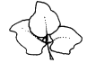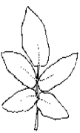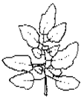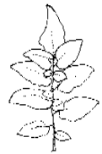
Dwarf Potato Leaf type Standard Peruvianum

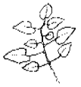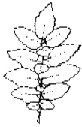
Pimpinellifolium Hirsutum
What colour are the flowers? (Rogue for uniformity)

white yellow orange other

What colour are the fruit before they ripen?

greenish white light green green dark green very dark green

What percent of plants were rogued before the flowers opened? _______________

Late season

What is the average vine length, as measured from the ground to the tip of the longest vine? ________ cm

What is the average distance between leaf nodes on the main stem? ________ cm

What is the average length of 10 petals, measured from different flowers of different plants? ________ mm

Fruit

Answer these questions when the fruit is fully ripe. Please observe several typical fruit and average your observations.

What shape is the fruit, viewed from the side? (Remove off-types before harvesting and mixing seeds)

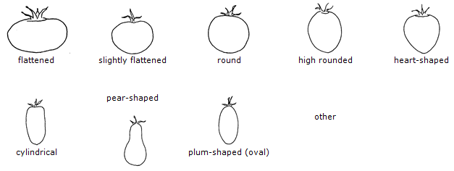

What shape is the fruit, sliced in cross-section?

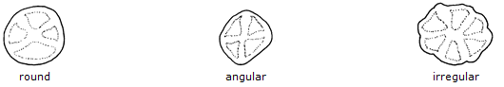

What is the average diameter of a fruit?

___________ cm

What is the average length of a fruit? (Recorded from stem end to blossom end, to one decimal place, at
Maturity)

___________ cm

How easy is it to pick the fruit?

_____ fruit detaches easily, tends to fall
_____ fruit detaches with a gentle pull or twist, tends to hang until picked
_____ fruit is difficult to detach when pulled, better to cut the stems

What is the exterior colour of the fruit?

green yellow orange pink red other

What colour is the interior flesh?

green yellow orange pink red other

What colour is the gel that surrounds the seeds?

yellow green red

How firm is the interior flesh?

soft intermediate firm
Does the skin have any noticeable hair or fuzziness (like a peach)?

none sparse hairs somewhat fuzzy densely fuzzy

How uniform is fruit size within a plant?

Various size fruit Slightly different sizes All the same size

What is the average number of fruits per plant? __________

What is the average weight of a fruit? __________ g

Seeds

What colour are the seeds?

Light yellow Dark yellow Grey Brown Dark brown

What is the total weight of seeds harvested from this variety?

________

Disease

Are there any signs of disease on the plants or fruit? (if so please take a picture and include a brief description)

Yes (picture) No
_____________________________________________________________________________________________________________________________________________________________________________________________________________________

Based on your knowledge and growing experience please rate this variety on the following characteristics on a scale from 1-5 (1 being very poor, 5 being excellent)

Productivity (how much/often did plants produce fruits): 1 2 3 4 5
Uniformity of fruit ripening (across entire plot): 1 2 3 4 5
Flavour: 1 2 3 4 5
Disease resistance: 1 2 3 4 5
Uniformity of fruit size: 1 2 3 4 5
Uniformity of fruit shape: 1 2 3 4 5
Suitability for your location/climate: 1 2 3 4 5
General customer appeal (i.e colouring/size) 1 2 3 4 5
Efficiency of picking 1 2 3 4 5
Ease of transport (i.e. bruising etc.) 1 2 3 4 5

Would you want to grow this variety again? Yes No

Please list any pros/cons related to growing this variety.
Pros Cons
________________________________ __________________________________
________________________________ __________________________________
________________________________ __________________________________
________________________________ __________________________________
________________________________ __________________________________

 | Vine Length | Internode distance | Petal length | Fruit Diameter | Fruit Length | Fruits per plant | Fruit Weight
1
2
3
4
5
6
7
8
9
10

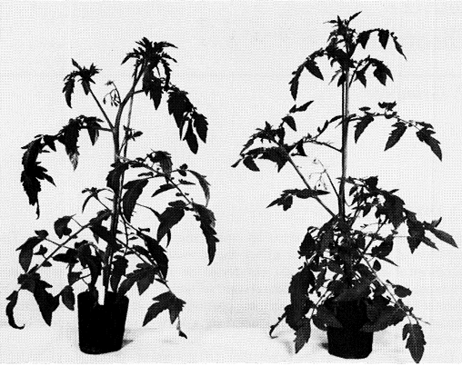
Example of an off-type tomato plant (right) which should be removed compared with normal plant.

Thank you for your help!

Illustrations: Seeds of Diversity Canada

