Page 1 of 5

PEPPER Descriptor Form
- (Form created by Seeds of Diversity Canada for The Bauta Family Initiative on Canadian Seed Security.)

Please observe several pepper plants in the same bed/row. Use a separate form for each variety.
If you cannot answer any of these questions, just leave them blank
For questions asking for averages, please take 10 measurements from different plants. See chart on last page.

Variety name ____________________ [ ] Variety name is unknown

Observer ____________________

Location ____________________

Population size How many seeds did you plant in total? _________

Germination rate What percent of the seeds germinated? _________

Final Population How many plants did you harvest seeds from at the end of the season? _________

Dates

Date when you sowed the seeds? ____________________

Date when 50% of the plants germinated? ____________________

Date when you transplanted the crop? ____________________

Date when the first flowers opened? ____________________

Date when the first fruits ripened? ____________________

Date when 50% of the fruits were ripe? ____________________

Date when the fruits were ready to be picked for seeds? ____________________

Rogueing for Seed Production

Rogueing should be done periodically throughout the season especially:
- At the seedling stage for lack of vigour
- As plants grow for off-type foliage
- At flowering for off-type flowers
- At fruiting for off-type fruits
- At harvest for ability to mature fruit/dry down
For peppers, characteristics to look for when rogueing include:
- Low vigour and leaf size may indicate a cross with a hot variety (Hot varieties typically have smaller leaves than sweet peppers)
- Evaluate fruit shape (some shape variation is to be expected)
- Rogue off colour fruits
- Evaluate wall thickness
- Check seed colour

*The best time to rogue for off- types is before flowers start to appear. After flowers appear rogueing should focus more on fruits and seeds

Early/Mid-season

Roughly how many plants were removed after rogueing for seedling vigour? (Typically remove about 10% of weakest seedlings and any seedlings showing signs of disease after germination)

____________ (# plants removed) or __________ % of plants

What colour is the stem of the young plant?

green green with purple stripes purple other

What shape is the stem?

cylindrical angled flattened

Does the stem have small hairs?

no hair sparse hairs intermediate dense hairs

What shape are the cotyledons? (Remove plants exhibiting different shaped leaves than rest of plot)

Deltoid Ovate Lanceolate Elong-deltoid
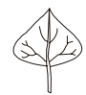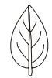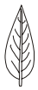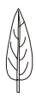

What colour are the leaves? (Rogue for off-types)

yellow light green green dark green
light purple purple other variegated (white patches or margins)

Are the leaves smooth or wrinkled? smooth wrinkled/curled

Flowers

Do the flowers droop downward or point upward? (Rogue for off-types and unhealthy plants)

downward intermediate upward

What colour are the flowers?

light yellow yellow yellow-green
purple with white base white with purple base white with purple margin
white purple other

What colour are the anthers (the pollen-carrying tips at the center of the flower)?

white yellow pale blue blue purple other

What is the position of the flower (recorded when flower is fully open)

Pendant Intermediate Erect
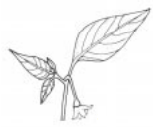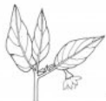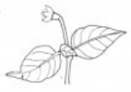
Fruit

What colour are the fruits when they are beginning to ripen, but not ready to harvest? (Remove off-types from seed harvest population)

white yellow green orange purple deep purple other

What colour are the fruit when they are ready to harvest? (Remove off-types from seed harvest population)

lemon-yellow pale orange-yellow orange-yellow pale orange orange
light red red dark red
purple brown black white other

Do the fruits droop downward or point upward?

downward intermediate upward

What shape are the ripe fruit?

elongated  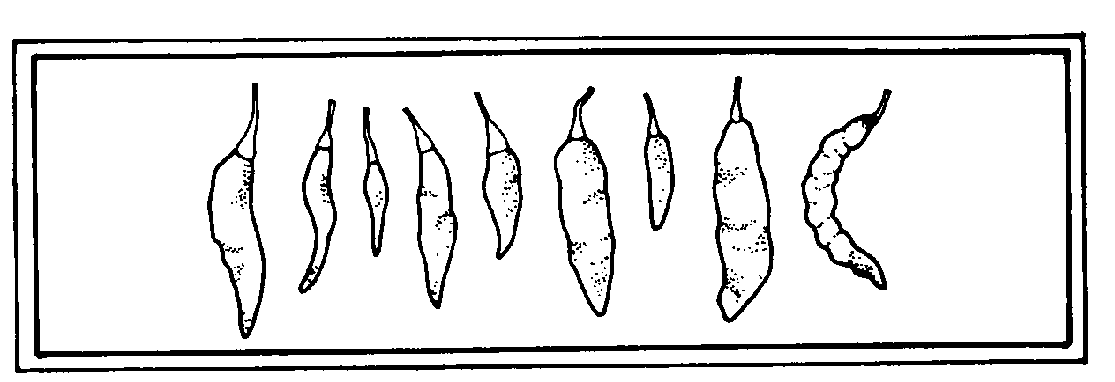 | almost round  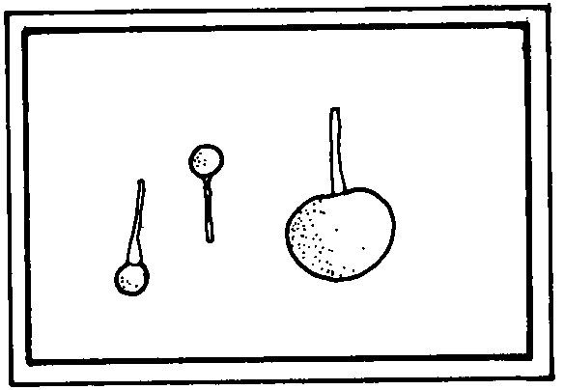 | triangular  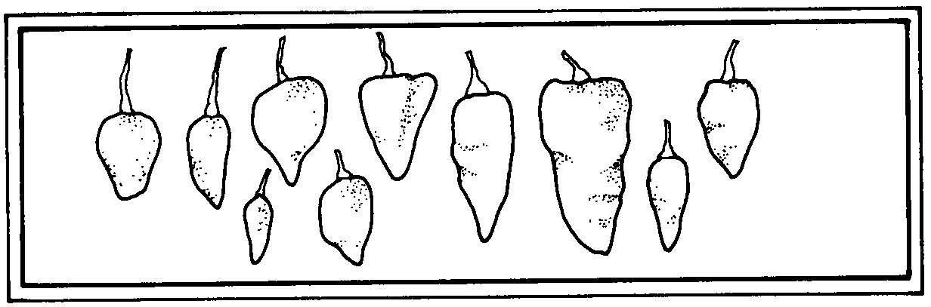
campanulate  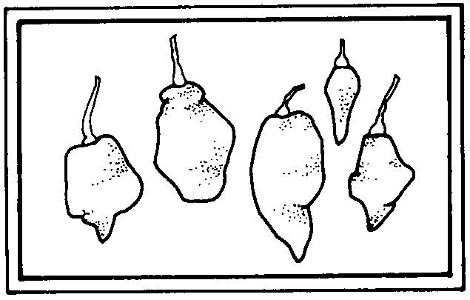 | blocky  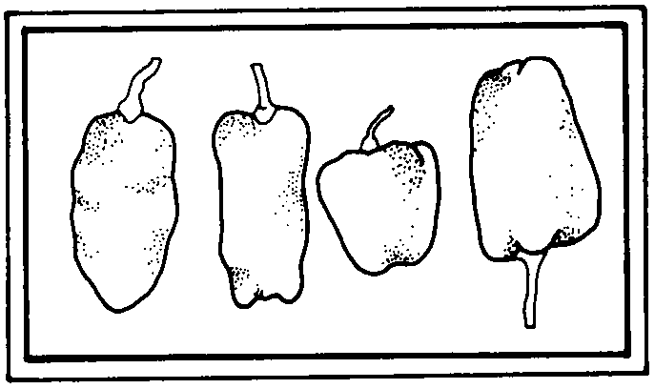 | other
Late season

What shape are the leaves?

deltoid  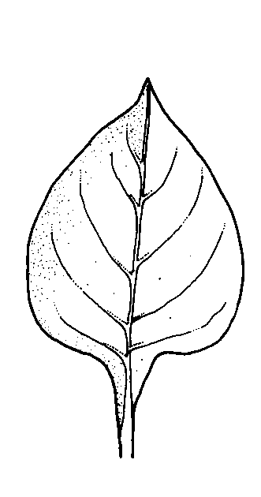 | ovate  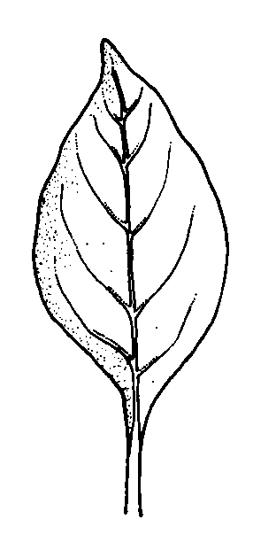 | lanceolate  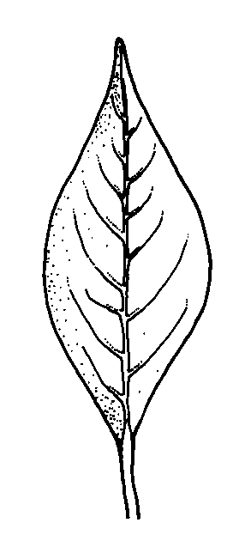
What is the average height of a plant (measured when first fruit has ripened on 50% of plants) ________cm

What is the average length of a fruit? ________ cm

What is the average weight of a fruit? ________ cm

What is the average length of a mature leaf, measured from the stem to the leaf tip? ________ cm

What is the average width of a mature leaf, measured at the widest point? ________ cm

How many stems do the mature plants have? single stem multiple stems
(look at the very bottom of the plant, not branches)

How dense are the small hairs on the stem (excluding the first two nodes below the shoot)?

Sparse Intermediate Dense
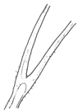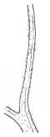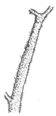

Do the plants tend to spread out or stand upright?

spreads sideways intermediate erect other

Seeds

What colour are the seeds? straw brown black other

What is the texture of the seeds' surface? smooth rough wrinkled

How many fruits did you harvest to save seeds from?

What is the total weight of seeds harvested from this variety? ________

Disease

Are there any signs of disease on the plants or fruit? (if so please take a picture and include a brief description)

Yes (picture) No
_____________________________________________________________________________________________________________________________________________________________________________________________________________________

Based on your knowledge and growing experience please rate this variety on the following characteristics on a scale from 1-5 (1 being very poor, 5 being excellent)

Productivity (how much/often did plants produce fruits): 1 2 3 4 5
Uniformity of fruit ripening (across entire plot): 1 2 3 4 5
Flavour: 1 2 3 4 5
Disease resistance: 1 2 3 4 5
Uniformity of fruit size: 1 2 3 4 5
Uniformity of fruit shape: 1 2 3 4 5
Suitability for your location/climate: 1 2 3 4 5
General customer appeal (i.e colouring/size) 1 2 3 4 5
Efficiency of picking 1 2 3 4 5
Ease of transport (i.e. bruising etc.) 1 2 3 4 5

Would you want to grow this variety again? Yes No

Please list any pros/cons related to growing this variety.
Pros Cons
________________________________ __________________________________
________________________________ __________________________________
________________________________ __________________________________
________________________________ __________________________________
________________________________ __________________________________

 | Plant Height | Fruit Length | Fruit Weight | Leaf Length | Leaf Width | Seeds per Fruit
1
2
3
4
5
6
7
8
9
10

Please write any notes or special observations that you would like to mention. Thank you for your help!

