Page 1 of 5

PEA Descriptor Form
- (Form created by Seeds of Diversity Canada for The Bauta Family Initiative on Canadian Seed Security.)

Please observe several pea plants in the same bed/row. Use a separate form for each variety.
If you cannot answer any of these questions, just leave them blank
For questions asking for averages, please take 10 measurements from different plants. See chart on last page.

Variety name ____________________ [ ] Variety name is unknown

Observer ____________________

Location ____________________

Population size How many seeds did you plant in total? _________

Germination rate What percentage of seeds germinated? _________

Final Population How many plants did you harvest seeds from at the end of the season? _________

Dates

Date when you sowed the seeds? ____________________

Date when 50% of the seeds germinated? ____________________

Date when the first flowers opened? ____________________

Date when the first pod was ready to harvest (for eating) ____________________

Date when the first dry seeds were ready to harvest? ____________________

Rogueing for Seed Production

Rogueing should be done periodically throughout the season especially:
- At the seedling stage for lack of vigour
- As plants grow for off-type foliage
- At flowering for off-type flowers
- At fruiting for off-type pods
- At harvest for ability to mature fruit/dry down
For peas, characteristics to look for when rogueing include:
- Seedling vigour (select for high germ rate in cold, wet soil)
- Vining or bush habit (very noticeable throughout growth phase)
- Flower colour and variation (pink/purple or white, number per node)
- Pod colour and variation (near maturity & at dry down, pod thickness, crispness, colour)
- Dry seed stage (wrinkled or smooth, colour)

*The best time to rogue for off- types is before flowers start to appear. After flowers appear rogueing should focus more on fruits and seeds

Early/Mid-Season

Roughly how many plants were removed after rogueing for seedling vigour? (Typically remove about 10% of weakest seedlings and any seedlings showing signs of disease after germination)

____________ (# plants removed) or __________ % of plants

What colour are the seed leaves (cotyledons)?

green yellow mixed other

Flower

Are the flowers white or do they have some colour? white colour mixed (details __________________)

What is the average number of flowers in a cluster? ________

Late Season

What is the position of the broadest part of the leaf?

at middle or slightly moderately towards base strongly towards base
towards base

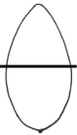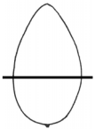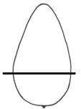

How strong is the leaf dentation (the degree of toothlike ridges surrounding the leaf) on leaves from the main stem?

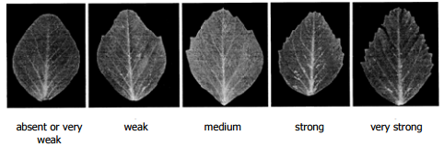

What is the average length of a leaf at maturity? ________ cm

What is the average width of a leaf at maturity? ________ cm

What is the average height of a plant, from the ground to tip, when
pods have reached edible maturity? ________ cm

What is the average distance between leaf nodes at maturity ________ cm

Pod

What type of pods does this pea have? edible (flat or round) non-edible mixed

What colour are the pods? green mixed other

What shape are the pods? (observe when they are still flat) curved straight mixed other

How much curvature does the pod exhibit when they are fully developed?

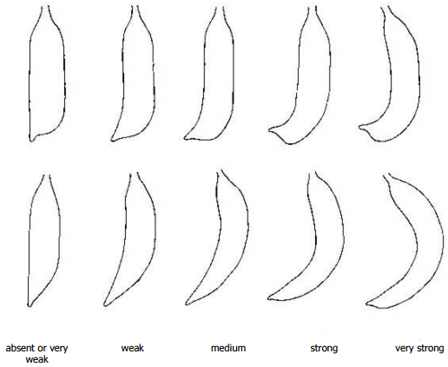

Are the tips of the pods pointed? (observe when still flat) pointed blunt mixed other

What is the average length of a pod at edible maturity? ________ cm

What is the average width of a pod at edible maturity? ________ cm

Seed

Does the seed's hilum (the scar where the
seed was attached to the pod) have a dark colour? yes no mixed

Most pea seeds are uniform green/white in colour, but some have other colours or markings. What colour are these seeds?

just uniform green/white coloured or with markings mixed

If coloured or with markings: what colour? green black brown blue grey purple mixed

what pattern? solid mottled spots mixed

Are the seeds smooth or wrinkled? smooth wrinkled mixed other

What is the average number of seeds per pod? ________

Are the stems round or flattened? (plants with flattened (or "fasciated") stems tend to produce clusters of flowers only at the tops of the plants)

round flattened mixed

What is the total weight of seeds harvested from this variety? ________

Disease

Are there any signs of disease on the plants or fruit? (if so please take a picture and include a brief description)

Yes (picture) No
_____________________________________________________________________________________________________________________________________________________________________________________________________________________

Based on your knowledge and growing experience please rate this variety on the following characteristics on a scale from 1-5 (1 being very poor, 5 being excellent)

Productivity (how much/often did plants produce fruits): 1 2 3 4 5
Uniformity of fruit ripening (across entire plot): 1 2 3 4 5
Flavour: 1 2 3 4 5
Disease resistance: 1 2 3 4 5
Uniformity of fruit size: 1 2 3 4 5
Uniformity of fruit shape: 1 2 3 4 5
Suitability for your location/climate: 1 2 3 4 5
General customer appeal (i.e colouring/size) 1 2 3 4 5
Efficiency of picking 1 2 3 4 5
Ease of transport (i.e. bruising etc.) 1 2 3 4 5

Would you want to grow this variety again? Yes No

Please list any pros/cons related to growing this variety.
Pros Cons
________________________________ __________________________________
________________________________ __________________________________
________________________________ __________________________________
________________________________ __________________________________
________________________________ __________________________________

 | Flowers in a cluster | Leaf Length | Leaf Width | Plant Height | Distance between nodes | Pod Length | Pod Width | Seeds per Pod
1
2
3
4
5
6
7
8
9
10

Please write any notes or special observations that you would like to mention. Thank you for your help!

